National University of Computer & Emerging Sciences Karachi Campus



Advanced Flappy Bird

Project Report

Section: C

22K-4589 Muhammad Talha Asim

Dec 2022

Introduction

This purpose of this project is to create a game similar to famous flappy bird. In the game, the user will control a bird which can move traditionally upwards, but it can also move downwards, rightwards, and leftwards in order to avoid obstacles.

Project Specification

Software Specs:

* Main function will be responsible for playing a song in background, displaying main menu, and calling the other functions.
* Coordinate function is responsible for updating x and y coordinates of cursor.
* Bound function will create game boundaries.
* Create Obstacle function will create obstacles whilst create bird function will create the bird.
* Crash function will terminate the game by calling end function if the bird crashes.
* The play function is what the input will be taken from user and position of bird and obstacles will be updated.

Tools and Technologies:

Programming Language: C language

Platform: Windows

Problem Analysis

Problem: How to generate different obstacles for the bird to avoid at different positions; How to run music in background, and How to update bird’s position in all 4 directions?

Input: Characters.

Process: take character as input in loop to move bird and generate obstacles using a position and flag array, and use playsound function for music.

Solution Design

The obstacles are generated using a function which uses rand() to generate obstacles of not only different heights but also of different symbols. Coordinate function was used to point cursor to different places on the console.

Bird position was updated by taking two variables to represent x and y coordinates, and adding or subtracting numbers accordingly to the key pressed.

Music ran simultaneously with the game using a built in function called PlaySound with command SND_ASYNC.

Project Breakdown

The first part was to create main menu, instructions menu, bird and its position, and a function to update cursor position. It was followed by border, side menu, collision detector and score counter, which, in turn, was followed by a game over screen and music. The last part was to write this report.

Results

In conclusion, the game, which is like flappy bird, is a result of an individual effort. The executable file plays a song in background whilst it generates obstacles, tallies the score for every obstacle dodged, and updates their position along with the bird’s position.

Acknowledgments

I would like to thank Mathbits website for showing me how to move cursor across console, and stackoverflow for showing me how to add music to my game. (links in sequence below)

<https://mathbits.com/MathBits/CompSci/Screen/screenfunctions2.htm>

<https://stackoverflow.com/questions/19895468/background-music-in-c>

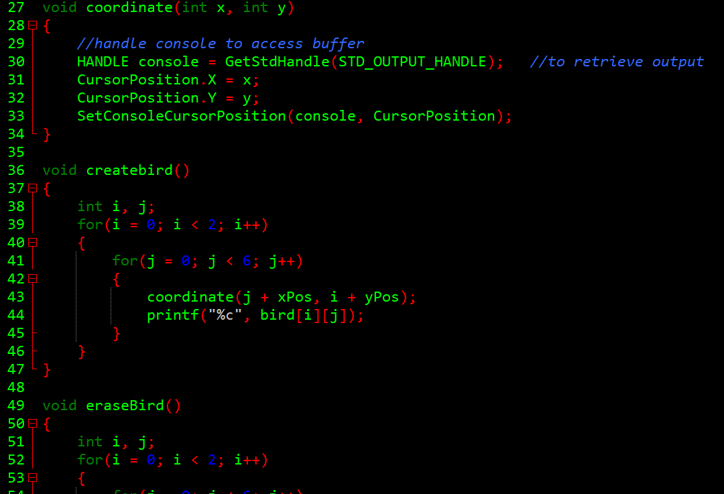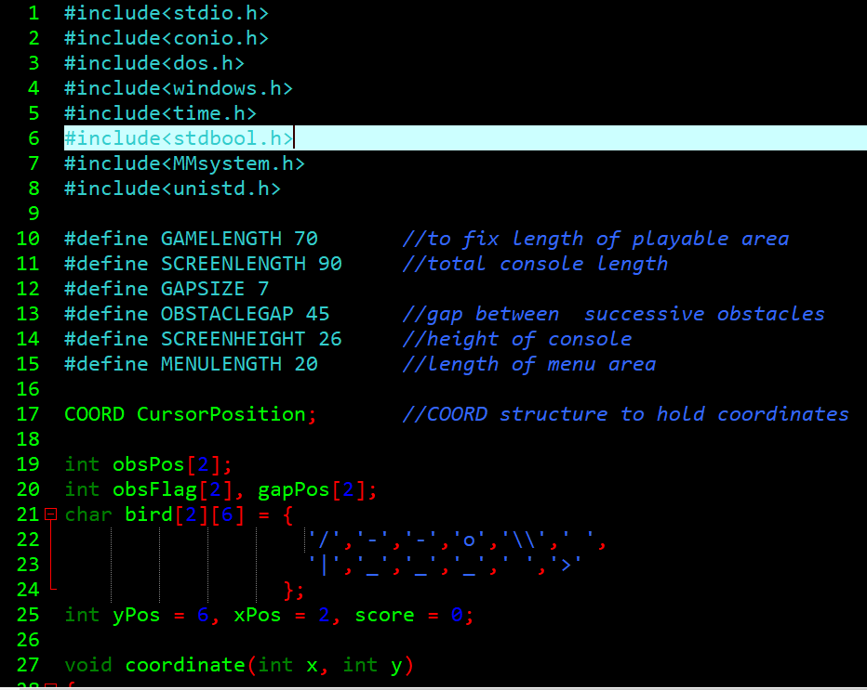The code

